Name _____________________________________________
Perceiving is Believing
Crash Course Psychology #7
- What is perception?
- What is a perceptual set?
Seeing is believing and believing is seeing.
- How does each of the following help understand what you see?
  - Context:
  - Culture:
- Form Perception:
  - Figure Ground
  - Proximity
  - Continuity
  - Closure
- Label the diagrams below with the above words (a-d only)
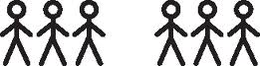
- Seeing depth:
  - Binocular cues:
  - Monocular cues:
    - Relative Size and Height:

    - Linear Perspective
    - Texture Gradient
    - Interposition
  - Label the pictures below (i-iv only):
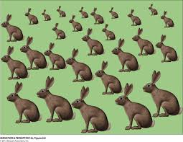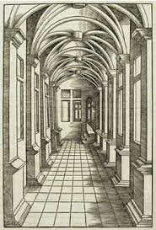

- Motion Perception:
  - _____________________ objects are _______________ and enlarging objects are _________________
  - Large objects move much more ____________________ than small objects going the same speed.
  - Your brain constructions your _____________________.

