Name _______________________________________
Crash Course Psychology #6: Homunculus
- Draw a homunculus
- Identify the difference between sensation and perception.
- Sounds move in _______________.
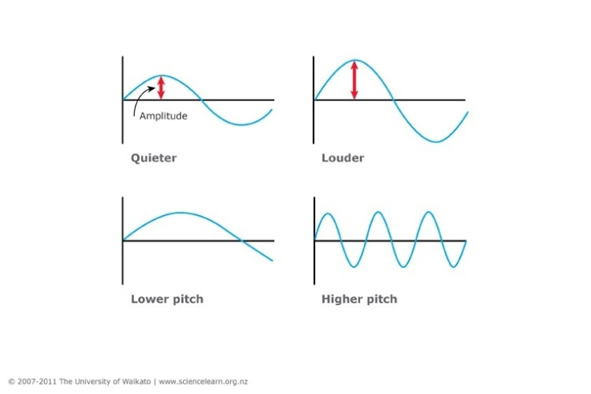
- What is directional stereophonic hearing?

- Number the order of the ear parts that are activated when sounds enter your ear.
  - _______ Inner Ear
  - _______ Ear Drum
  - _______ Anvil
  - _______ Stirrup
  - _______ Outer Ear
  - _______ Hammer
  - _______ Cochlea
  - _______ Auditory Cortex
  - _______ Middle Ear
  - _______ Cochlear hair Cells
  - _______ Auditory Nerve
- Name the five tastes.

- What is synesthesia?

- What are the two types of chemical senses?

- How we __________ about a smell, and our ________________ of it, is often tangled up in our ________________ with that scent.
- Why are scents linked to memories?
- How does touch (or lack of touch) affect development in animal and human babies?
- What four senses make up the sense of touch?
- Define:
  - Kinesthesis
  - Vestibular sense

Name _____________________________________________
Perceiving is Believing
Crash Course Psychology #7
- What is perception?
- What is a perceptual set?
Seeing is believing and believing is seeing.
- How does each of the following help understand what you see?
  - Context:
  - Culture:
- Form Perception:
  - Figure Ground
  - Proximity
  - Continuity
  - Closure
- Label the diagrams below with the above words (a-d only)
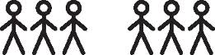
- Seeing depth:
  - Binocular cues:
  - Monocular cues:
    - Relative Size and Height:

    - Linear Perspective
    - Texture Gradient
    - Interposition
  - Label the pictures below (i-iv only):
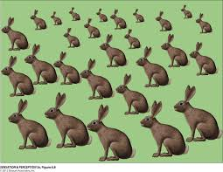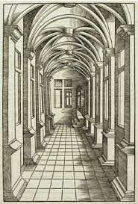

- Motion Perception:
  - _____________________ objects are _______________ and enlarging objects are _________________
  - Large objects move much more ____________________ than small objects going the same speed.
  - Your brain constructions your _____________________.

