Psych Crash Course #26
Emotion, Stress and Health
**Our feelings and the behaviors they can drive also affect the minds, bodies, and health of those around us.**
**People with a positive outlook on life live longer.**

Paul Eckman: All facial expressions are the same across culture
Facial Feedback Theory:

Why do patients who use Botox feel happier and experience less depression?

Introverts | Extroverts

Gestures differ from culture to culture. They’re also about our ______________________ experience of what we’re thinking.

List the ten basic emotions:

What are some emotions people feel should be added?

What is the two-dimensional model?

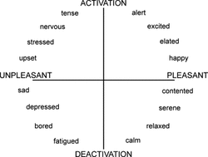
**We often overestimate the duration of our bad moods and underestimate our capacity to adapt and bounce back from traumas.**

What is stress?

Where does stress fit into? Define the categories below:
- Catastrophes
- Significant life changes
- Everyday inconveniences

Stress is ultimately good- short lived stresses can lead to focus and kick the body systems into fixing yourself like from wounds and releasing adrenaline and cortisol.
Chronic stress is bad. List some side effects of chronic stress:

Pessimism and Depression
**People characterized by their optimism, happiness, love, and positive feelings often live ______________________.
This can be explained by:
- Lifestyle or behavioral factors
- Social factors
- Biological factors

